When clicking on the Link (1):
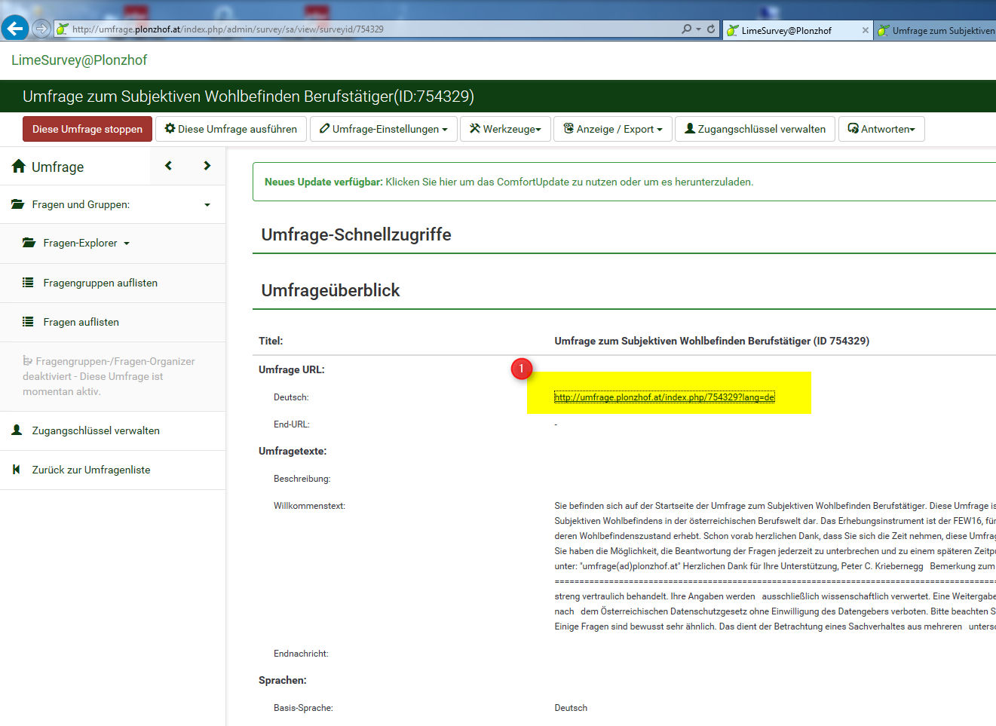

Then the survey opens and I get though the CAPTCHA, the introduction, the question group 1, but when getting to the first randomized question group (FEW16-1) that contains as the three following ones 4 questions, only two questions are displayed, and there is a stopper, because when answering these two questions shown, I get the message to answer to all questions .. (I think Limesurvey thinks/references here to the four questions the group normally has), I can’t go on with my survey!

This Screenshot shows, that only two questions appear, and both of them are answered … but I can’t go on, move forward….
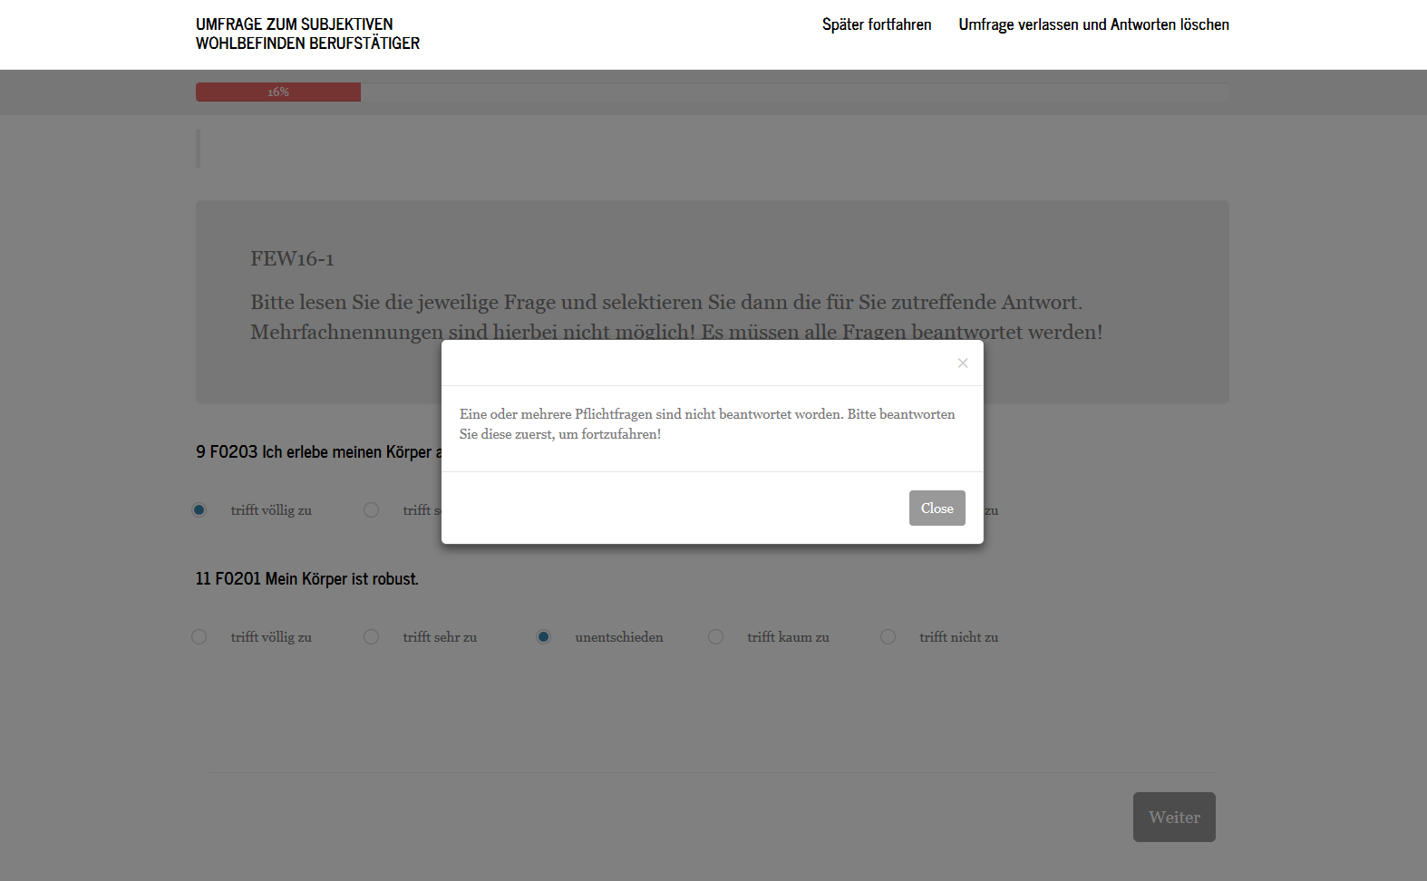

This Screenshot proves that questions group “FEW16-1” contains 4 questions:
