--Failed to Add New User Error Msg
This is two examples of trying to create a new survey user in newly installed LS3.8.1 – generates a ‘failed to add user’ error msg – does not generate the password email – But the new user is displayed under ‘Manage Survey Administrators’
User ID#2
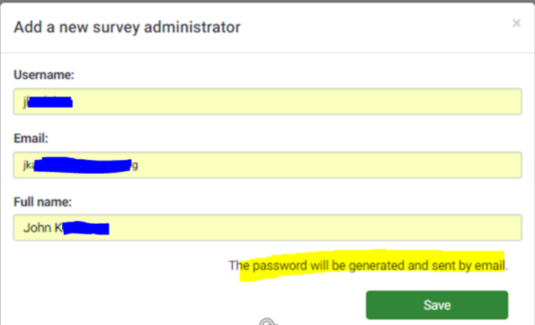
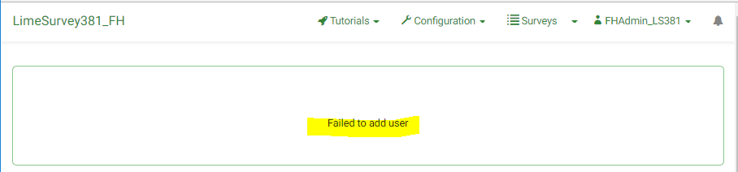
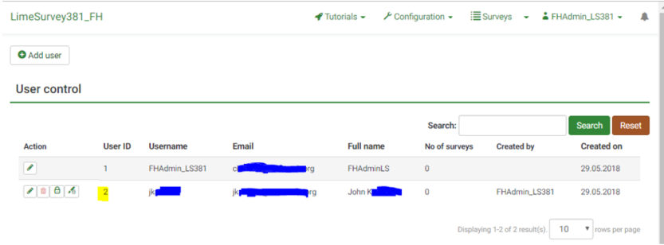
User ID#3
