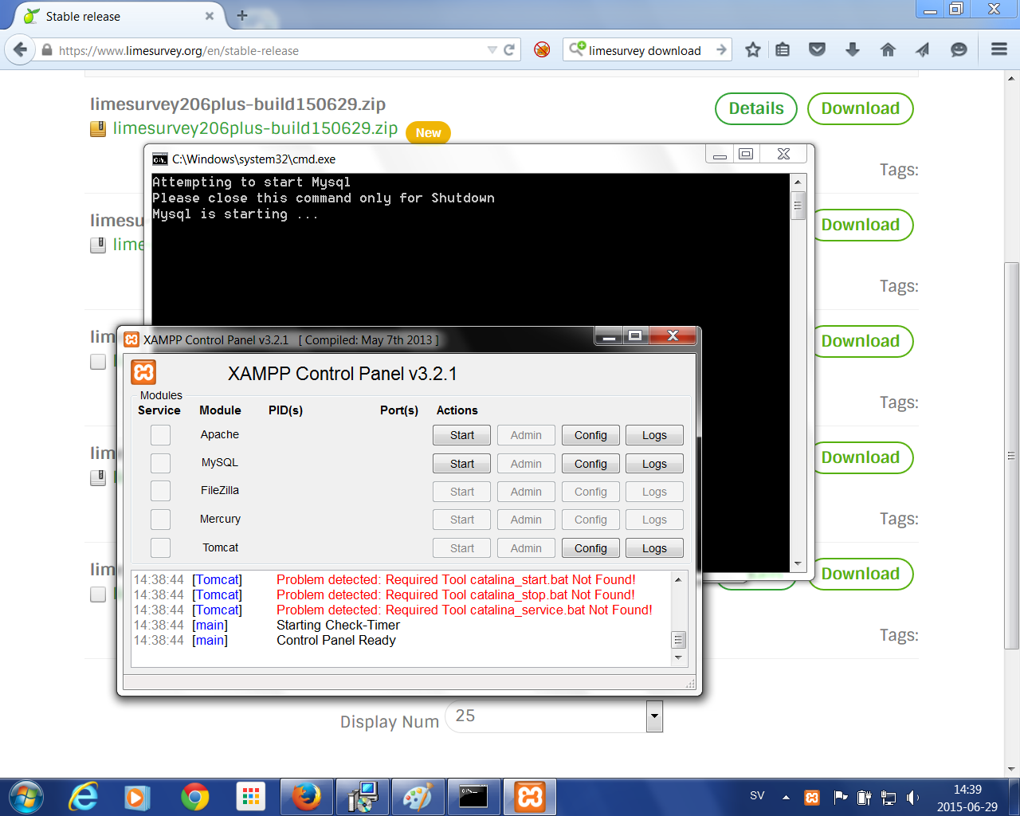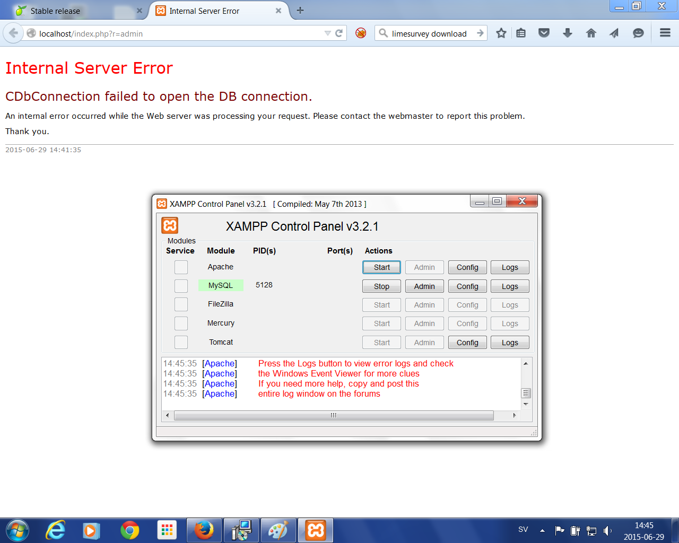

LOG
14:44:09 [main] Initializing Control Panel
14:44:09 [main] Windows Version: Windows 7 Professional SP1 64-bit
14:44:09 [main] XAMPP Version: 5.6.8
14:44:09 [main] Control Panel Version: 3.2.1 [ Compiled: May 7th 2013 ]
14:44:09 [main] You are not running with administrator rights! This will work for
14:44:09 [main] most application stuff but whenever you do something with services
14:44:09 [main] there will be a security dialogue or things will break! So think
14:44:09 [main] about running this application with administrator rights!
14:44:09 [main] XAMPP Installation Directory: "c:\xampp\"
14:44:09 [main] Checking for prerequisites
14:44:09 [main] All prerequisites found
14:44:09 [main] Initializing Modules
14:44:09 [Apache] Problem detected!
14:44:09 [Apache] Port 80 in use by "Unable to open process" with PID 6720!
14:44:09 [Apache] Apache WILL NOT start without the configured ports free!
14:44:09 [Apache] You need to uninstall/disable/reconfigure the blocking application
14:44:09 [Apache] or reconfigure Apache and the Control Panel to listen on a different port
14:44:09 [Apache] Problem detected!
14:44:09 [Apache] Port 443 in use by "Unable to open process" with PID 6720!
14:44:09 [Apache] Apache WILL NOT start without the configured ports free!
14:44:09 [Apache] You need to uninstall/disable/reconfigure the blocking application
14:44:09 [Apache] or reconfigure Apache and the Control Panel to listen on a different port
14:44:09 [mysql] Problem detected!
14:44:09 [mysql] Port 3306 in use by "Unable to open process"!
14:44:09 [mysql] MySQL WILL NOT start without the configured ports free!
14:44:09 [mysql] You need to uninstall/disable/reconfigure the blocking application
14:44:09 [mysql] or reconfigure MySQL and the Control Panel to listen on a different port
14:44:09 [main] The FileZilla module is disabled
14:44:09 [main] The Mercury module is disabled
14:44:09 [Tomcat] Problem detected: Tomcat Not Found!
14:44:09 [Tomcat] Disabling Tomcat buttons
14:44:09 [Tomcat] Run this program from your XAMPP root directory!
14:44:09 [Tomcat] Problem detected: Required Tool catalina_start.bat Not Found!
14:44:09 [Tomcat] Problem detected: Required Tool catalina_stop.bat Not Found!
14:44:09 [Tomcat] Problem detected: Required Tool catalina_service.bat Not Found!
14:44:09 [main] Starting Check-Timer
14:44:09 [main] Control Panel Ready
14:44:11 [Apache] Problem detected!
14:44:11 [Apache] Port 80 in use by "Unable to open process" with PID 6720!
14:44:11 [Apache] Apache WILL NOT start without the configured ports free!
14:44:11 [Apache] You need to uninstall/disable/reconfigure the blocking application
14:44:11 [Apache] or reconfigure Apache and the Control Panel to listen on a different port
14:44:11 [Apache] Problem detected!
14:44:11 [Apache] Port 443 in use by "Unable to open process" with PID 6720!
14:44:11 [Apache] Apache WILL NOT start without the configured ports free!
14:44:11 [Apache] You need to uninstall/disable/reconfigure the blocking application
14:44:11 [Apache] or reconfigure Apache and the Control Panel to listen on a different port
14:44:11 [Apache] Attempting to start Apache app...
14:44:11 [Apache] Status change detected: running
14:44:12 [Apache] Status change detected: stopped
14:44:12 [Apache] Error: Apache shutdown unexpectedly.
14:44:12 [Apache] This may be due to a blocked port, missing dependencies,
14:44:12 [Apache] improper privileges, a crash, or a shutdown by another method.
14:44:12 [Apache] Press the Logs button to view error logs and check
14:44:12 [Apache] the Windows Event Viewer for more clues
14:44:12 [Apache] If you need more help, copy and post this
14:44:12 [Apache] entire log window on the forums
14:44:14 [Apache] Problem detected!
14:44:14 [Apache] Port 80 in use by "Unable to open process" with PID 6720!
14:44:14 [Apache] Apache WILL NOT start without the configured ports free!
14:44:14 [Apache] You need to uninstall/disable/reconfigure the blocking application
14:44:14 [Apache] or reconfigure Apache and the Control Panel to listen on a different port
14:44:14 [Apache] Problem detected!
14:44:14 [Apache] Port 443 in use by "Unable to open process" with PID 6720!
14:44:14 [Apache] Apache WILL NOT start without the configured ports free!
14:44:14 [Apache] You need to uninstall/disable/reconfigure the blocking application
14:44:14 [Apache] or reconfigure Apache and the Control Panel to listen on a different port
14:44:14 [Apache] Attempting to start Apache app...
14:44:35 [Apache] Problem detected!
14:44:35 [Apache] Port 80 in use by "Unable to open process" with PID 6720!
14:44:35 [Apache] Apache WILL NOT start without the configured ports free!
14:44:35 [Apache] You need to uninstall/disable/reconfigure the blocking application
14:44:35 [Apache] or reconfigure Apache and the Control Panel to listen on a different port
14:44:35 [Apache] Problem detected!
14:44:35 [Apache] Port 443 in use by "Unable to open process" with PID 6720!
14:44:35 [Apache] Apache WILL NOT start without the configured ports free!
14:44:35 [Apache] You need to uninstall/disable/reconfigure the blocking application
14:44:35 [Apache] or reconfigure Apache and the Control Panel to listen on a different port
14:44:35 [Apache] Attempting to start Apache app...
14:44:35 [Apache] Status change detected: running
14:44:36 [Apache] Status change detected: stopped
14:44:36 [Apache] Error: Apache shutdown unexpectedly.
14:44:36 [Apache] This may be due to a blocked port, missing dependencies,
14:44:36 [Apache] improper privileges, a crash, or a shutdown by another method.
14:44:36 [Apache] Press the Logs button to view error logs and check
14:44:36 [Apache] the Windows Event Viewer for more clues
14:44:36 [Apache] If you need more help, copy and post this
14:44:36 [Apache] entire log window on the forums
14:44:42 [Apache] Problem detected!
14:44:42 [Apache] Port 80 in use by "Unable to open process" with PID 6720!
14:44:42 [Apache] Apache WILL NOT start without the configured ports free!
14:44:42 [Apache] You need to uninstall/disable/reconfigure the blocking application
14:44:42 [Apache] or reconfigure Apache and the Control Panel to listen on a different port
14:44:42 [Apache] Problem detected!
14:44:42 [Apache] Port 443 in use by "Unable to open process" with PID 6720!
14:44:42 [Apache] Apache WILL NOT start without the configured ports free!
14:44:42 [Apache] You need to uninstall/disable/reconfigure the blocking application
14:44:42 [Apache] or reconfigure Apache and the Control Panel to listen on a different port
14:44:42 [Apache] Attempting to start Apache app...
14:44:42 [Apache] Status change detected: running
14:44:43 [Apache] Status change detected: stopped
14:44:43 [Apache] Error: Apache shutdown unexpectedly.
14:44:43 [Apache] This may be due to a blocked port, missing dependencies,
14:44:43 [Apache] improper privileges, a crash, or a shutdown by another method.
14:44:43 [Apache] Press the Logs button to view error logs and check
14:44:43 [Apache] the Windows Event Viewer for more clues
14:44:43 [Apache] If you need more help, copy and post this
14:44:43 [Apache] entire log window on the forums
14:45:31 [Apache] Problem detected!
14:45:31 [Apache] Port 80 in use by "Unable to open process" with PID 6720!
14:45:31 [Apache] Apache WILL NOT start without the configured ports free!
14:45:31 [Apache] You need to uninstall/disable/reconfigure the blocking application
14:45:31 [Apache] or reconfigure Apache and the Control Panel to listen on a different port
14:45:31 [Apache] Problem detected!
14:45:31 [Apache] Port 443 in use by "Unable to open process" with PID 6720!
14:45:31 [Apache] Apache WILL NOT start without the configured ports free!
14:45:31 [Apache] You need to uninstall/disable/reconfigure the blocking application
14:45:31 [Apache] or reconfigure Apache and the Control Panel to listen on a different port
14:45:31 [Apache] Attempting to start Apache app...
14:45:31 [Apache] Status change detected: running
14:45:32 [Apache] Status change detected: stopped
14:45:32 [Apache] Error: Apache shutdown unexpectedly.
14:45:32 [Apache] This may be due to a blocked port, missing dependencies,
14:45:32 [Apache] improper privileges, a crash, or a shutdown by another method.
14:45:32 [Apache] Press the Logs button to view error logs and check
14:45:32 [Apache] the Windows Event Viewer for more clues
14:45:32 [Apache] If you need more help, copy and post this
14:45:32 [Apache] entire log window on the forums
14:45:35 [Apache] Problem detected!
14:45:35 [Apache] Port 80 in use by "Unable to open process" with PID 6720!
14:45:35 [Apache] Apache WILL NOT start without the configured ports free!
14:45:35 [Apache] You need to uninstall/disable/reconfigure the blocking application
14:45:35 [Apache] or reconfigure Apache and the Control Panel to listen on a different port
14:45:35 [Apache] Problem detected!
14:45:35 [Apache] Port 443 in use by "Unable to open process" with PID 6720!
14:45:35 [Apache] Apache WILL NOT start without the configured ports free!
14:45:35 [Apache] You need to uninstall/disable/reconfigure the blocking application
14:45:35 [Apache] or reconfigure Apache and the Control Panel to listen on a different port
14:45:35 [Apache] Attempting to start Apache app...
14:45:35 [Apache] Status change detected: running
14:45:35 [Apache] Status change detected: stopped
14:45:35 [Apache] Error: Apache shutdown unexpectedly.
14:45:35 [Apache] This may be due to a blocked port, missing dependencies,
14:45:35 [Apache] improper privileges, a crash, or a shutdown by another method.
14:45:35 [Apache] Press the Logs button to view error logs and check
14:45:35 [Apache] the Windows Event Viewer for more clues
14:45:35 [Apache] If you need more help, copy and post this
14:45:35 [Apache] entire log window on the forums

