Within the „Einfacher Statistik“ and the output/display of only the „complete “ Entries:
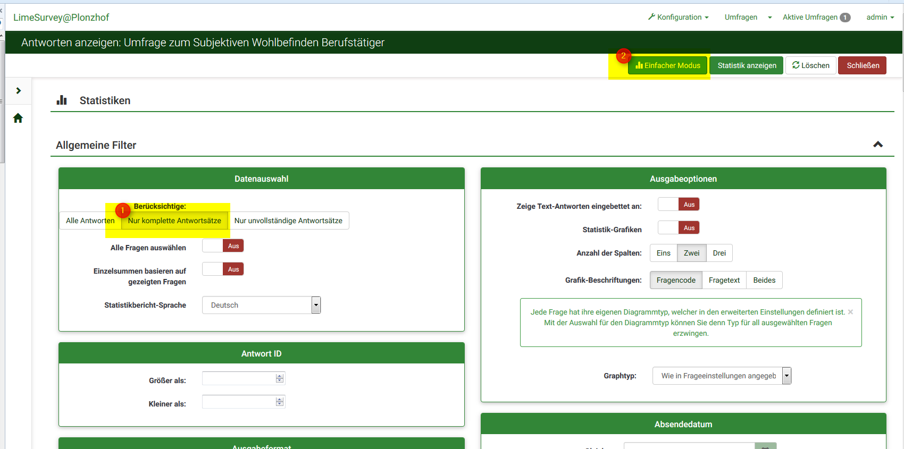
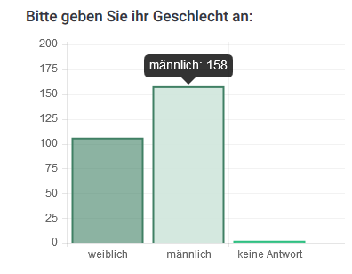
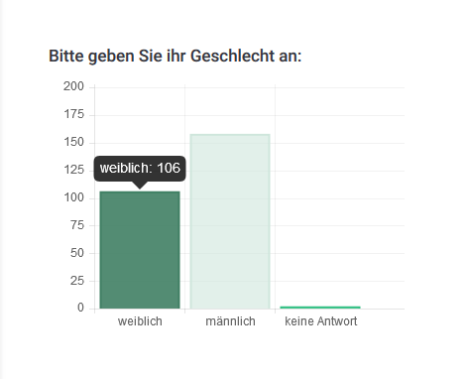

There are 106 female and 158 male participants sohown, even though according tot he exported excel file there shell be 99 female and 148 male ones.

This is the summary of all answers, and the complete 247 participantes seem to be correct! But I can’t explain where the 38 ones are assigned to one the two groups to get the 264 shown in the statistics graph.
