Here the Version of Lime Survey and the Server Settings:

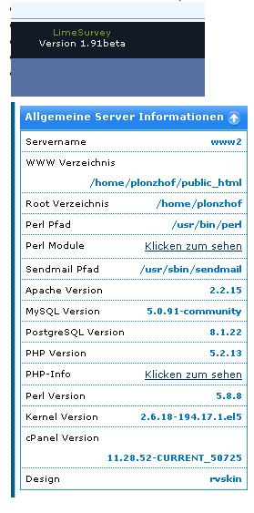

Here the label Set:

For me it seems a bit strange, because I’m not able to input the translations to “German” and “German informal”, because they were not saved!
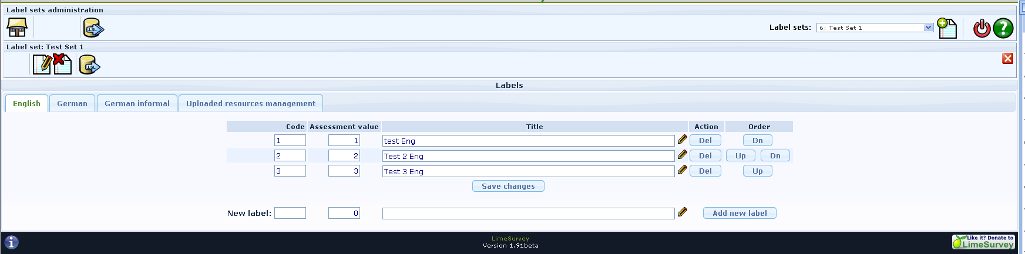

Here the German Screen:
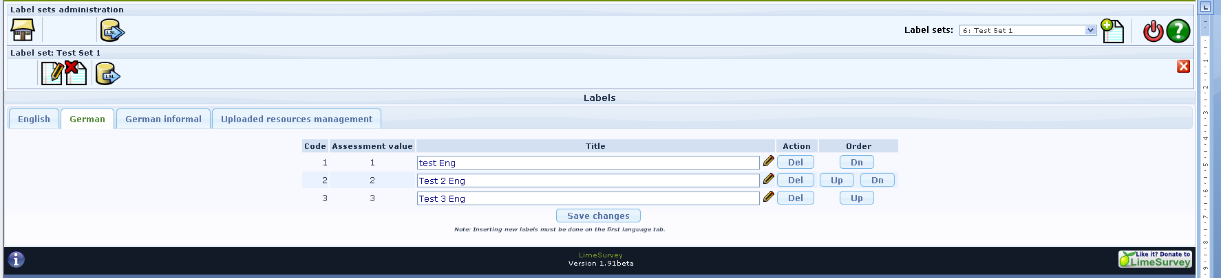

Error 1: When I make some changes in the texts of German and click on Save changes, I get back to the English Tab and my changes were not saved!

Here the Settings for the survey, the question group and even the question:
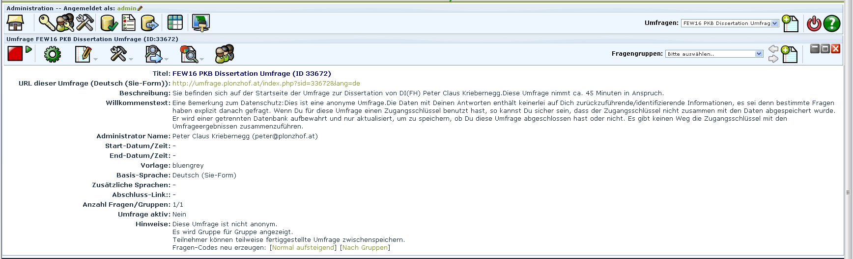

Here the Question:
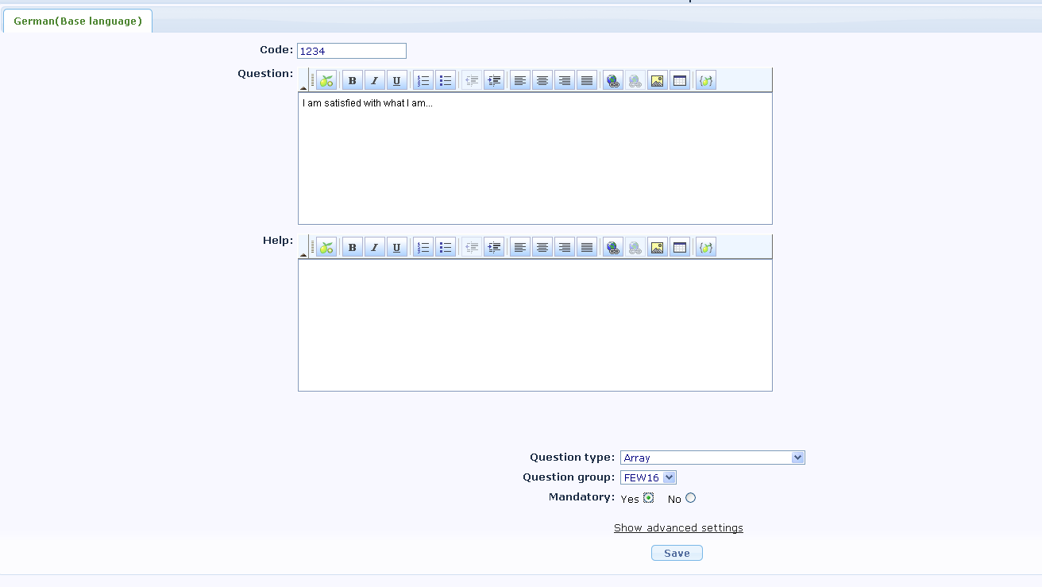

The base Language seems to come out of the global settings, this language is included in the label set anyway1
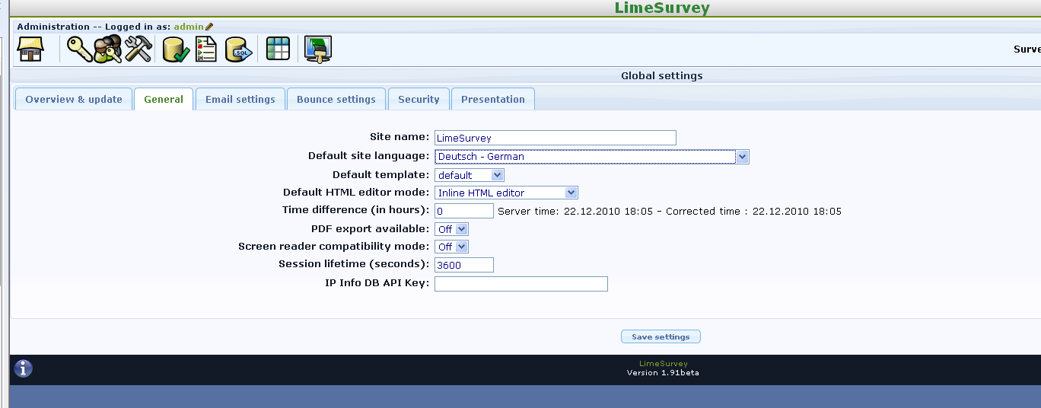

Here the “error” when trying to select a label set:
It is shown, but in a strange way [FALSE ..] as I think and I’m not able to add it.
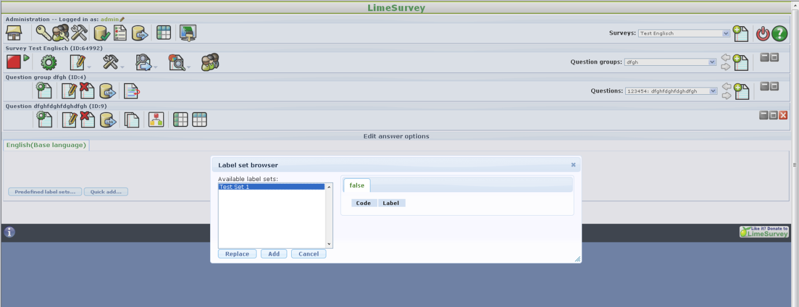

I posted it in the forum http://www.limesurvey.org/en/support/forums/1-installation-a-update-issues/54501-problems-with-label-sets-and-multilanguage#54504 were I was told to report ist as bug, because “… it seem to have a problem with Predefined Label set ... button, it this your problem ?”

