I enter LimeSurvey and click on the statistics icon on the right (see red arrow)
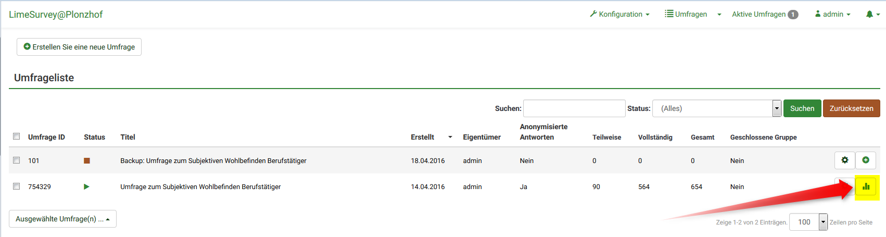

Here I can do whatever I want, the result are not shown!
