ERRO MATRIZ (TEXT)

PHASE 01 – INSERT TYPE QUESTION

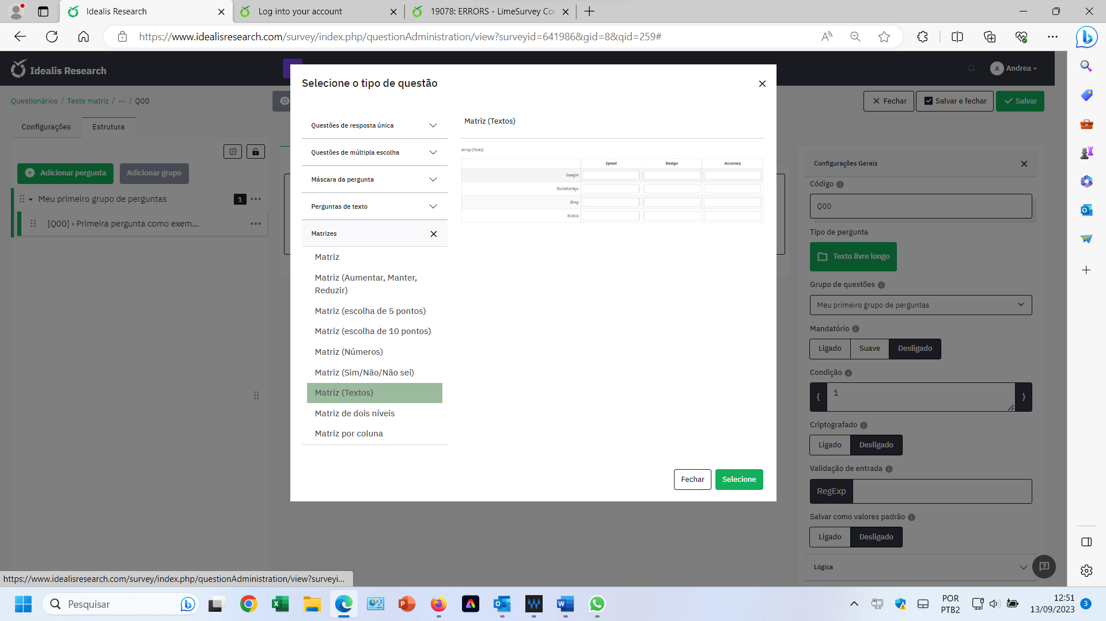

PHASE 02 – INSERT SUBQUESTIONS
EIXO Y
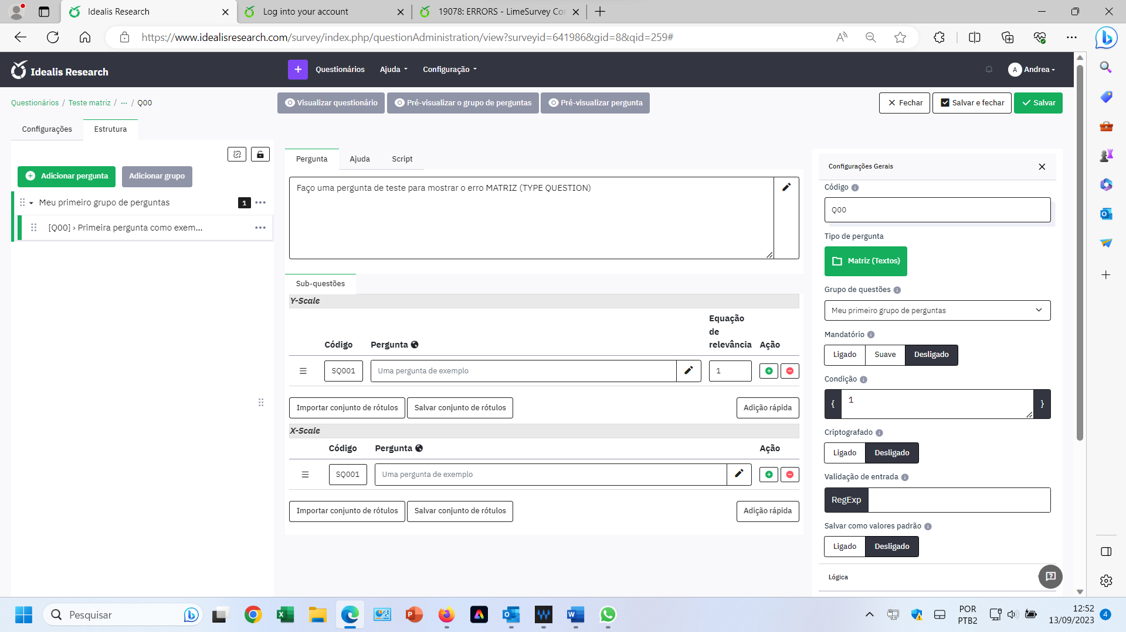

INSERT EIXO X
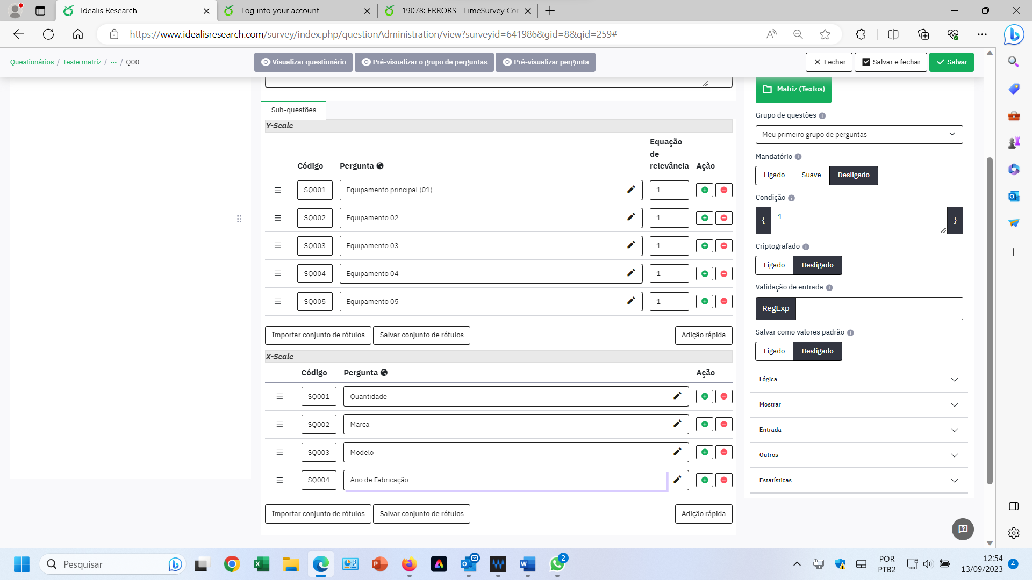

PHASE 03 - ERROR IN SAVE
UNSTABLE SYSTEM
TENTATIVE 01

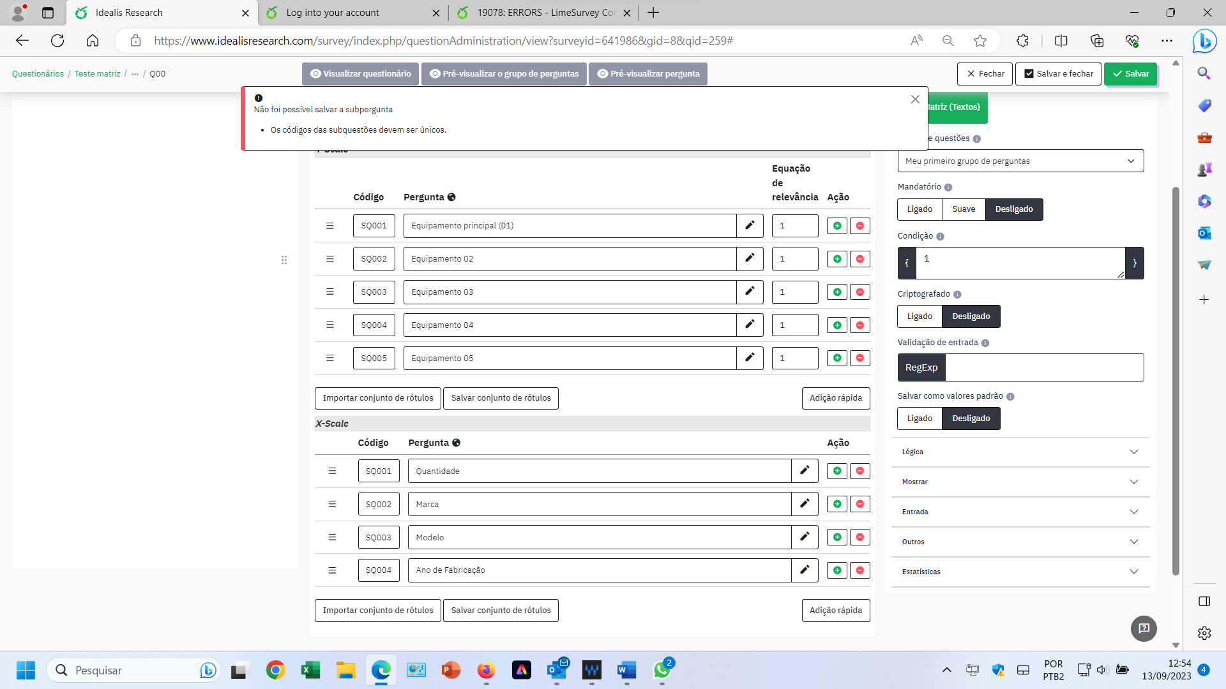

TENTATIVE 02
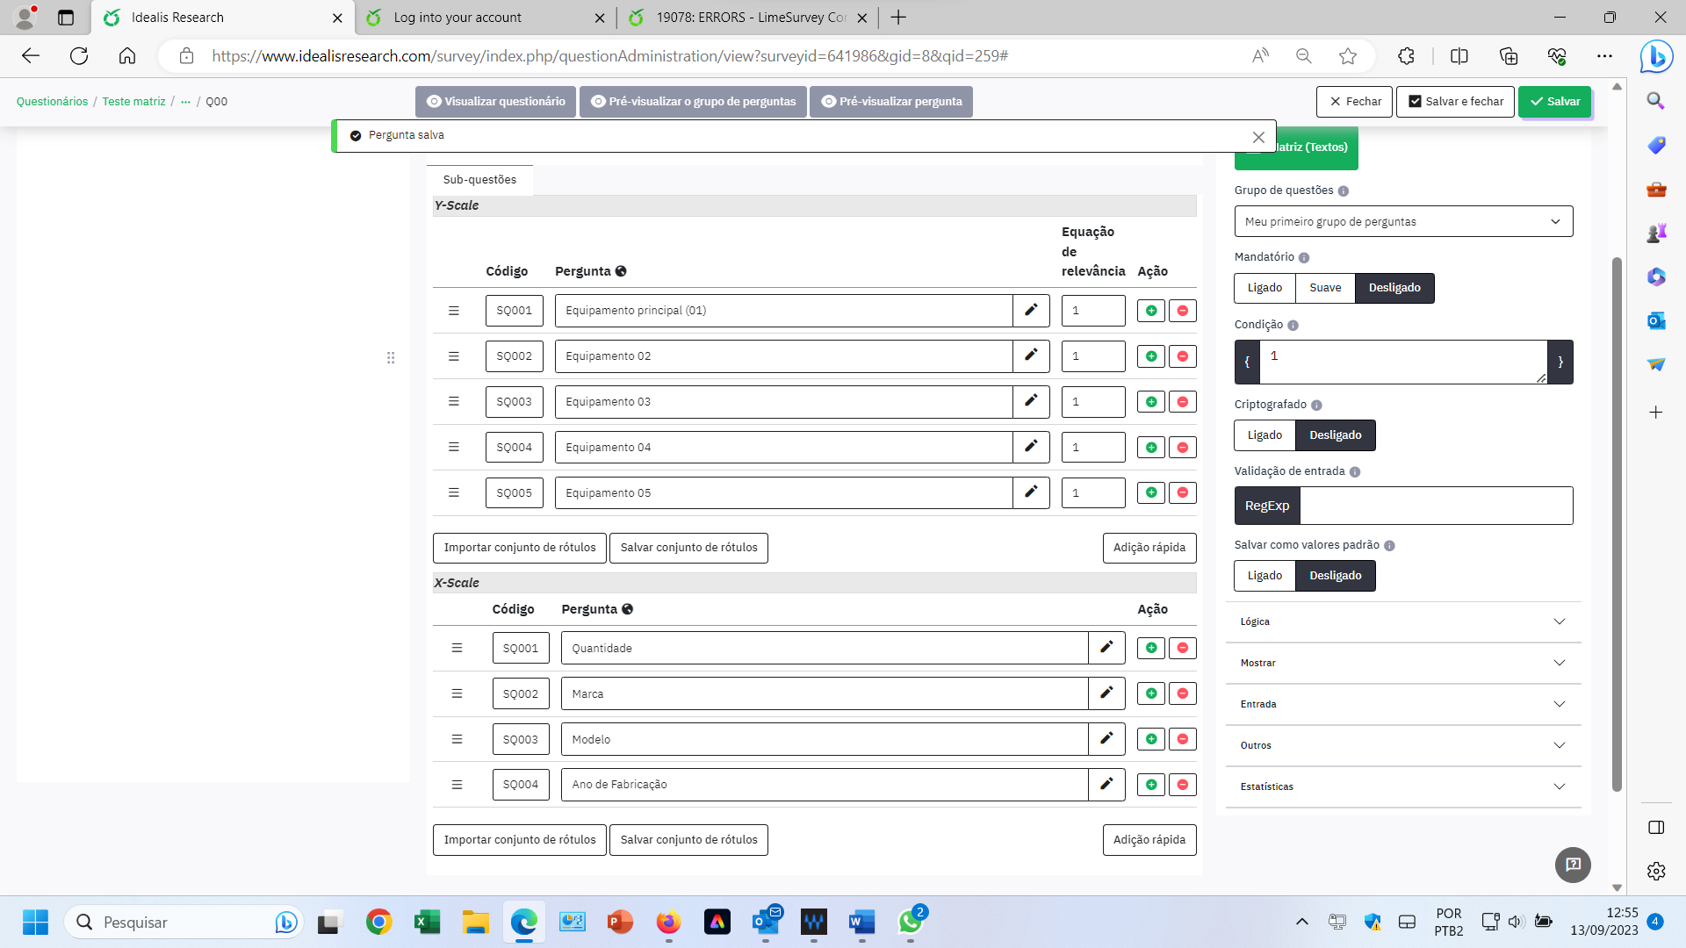

PHASE 04 - PREVIEW QUESTION

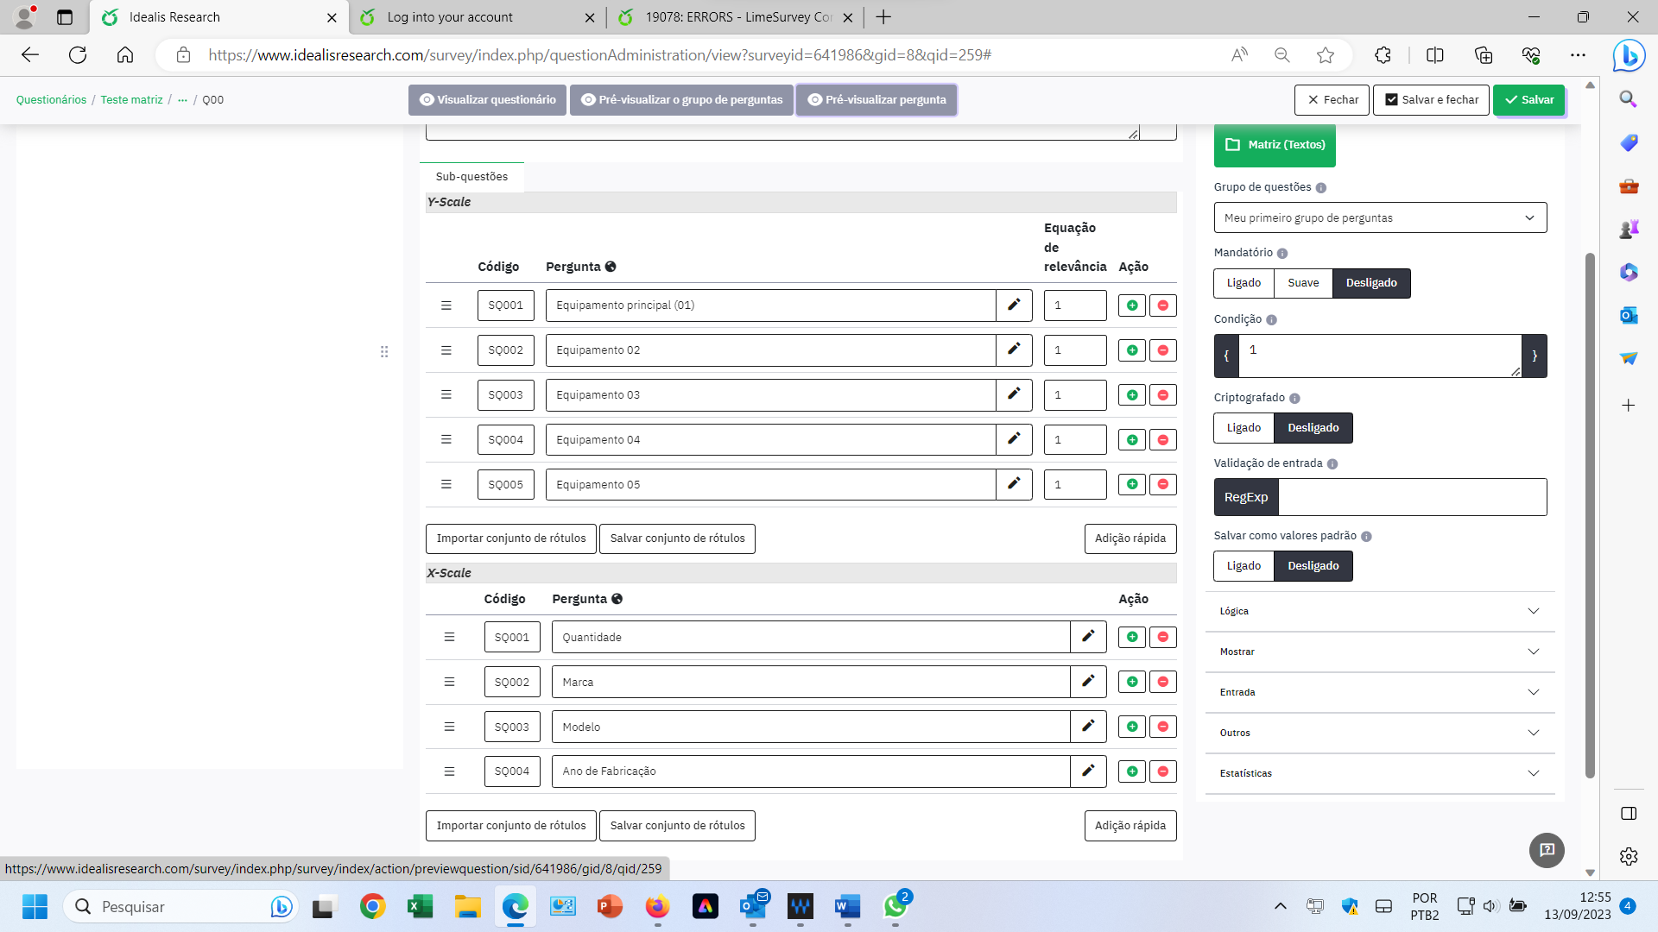

PHASE 05 - ERROR IN QUESTION – SQ001, IN Y, DOESN'T SHOW
