While trying to add java script in the question or group source, it’s not saving and script disappears.

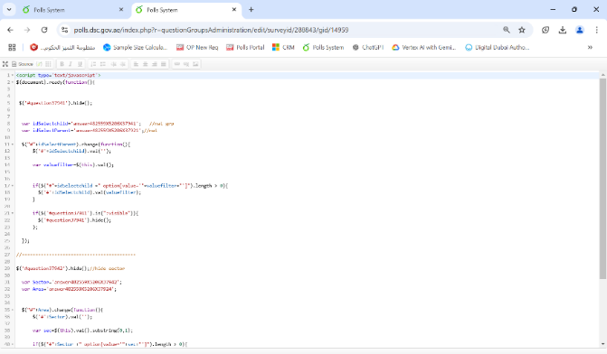

* While exporting a question group with a certain java script from the old version (5.x) , and importing it into the new version (6.x), the script wasn’t imported.

