We want an ability to turn off pjax for external links:
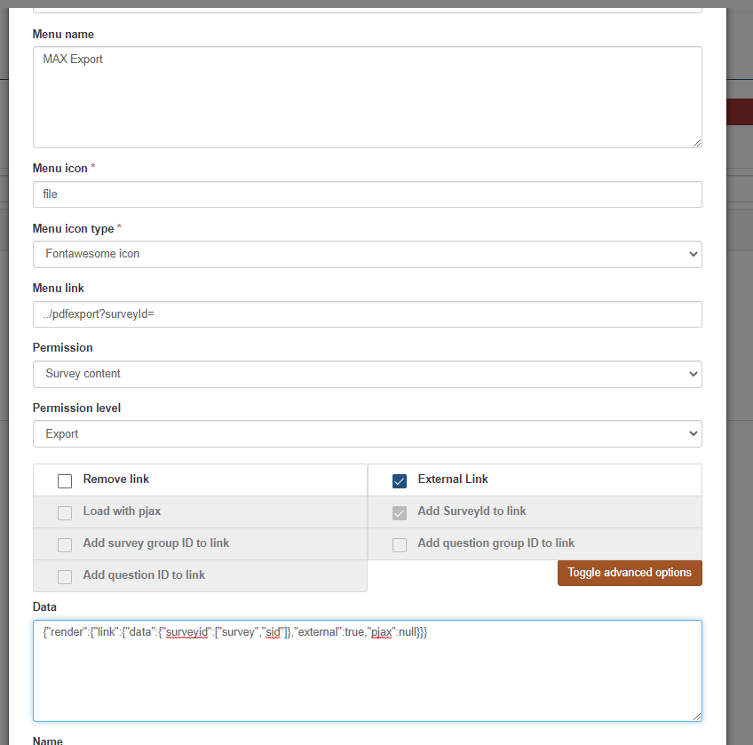

However, after the change, “pjax” still shows up on the external link:
