Topic:
Keep token linked info (attributes) when changing language in survey
Your LimeSurvey version: 6.15.20
Own server or LimeSurvey hosting: Lime survey Hosting
Survey theme/template: Fruity
I have built two multilingual and restricted to a specific group of participants surveys in LimeSurvey. In one of them, for some conditional questions, I use attributes from the participant table (e.g., TOKEN:ATTRIBUTE_1 = 1) so the survey doesn’t need to ask for information I already have. In the second one, I use attributes from the participant table just to give a reference to the participant at the top of every group of qüestions. As this second survey is less complex and exposes the same bug the first one does, I use the second one for this bug report.
Step 1: Programming and expected output
Screenshot 1 (Use of token attribute, language A)
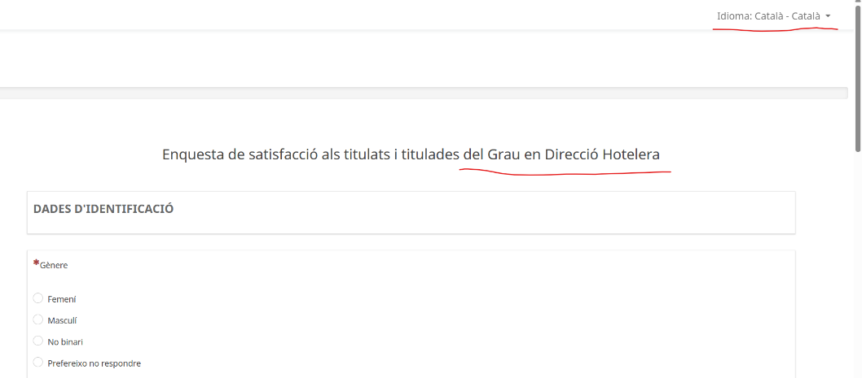
Screenshot 2 (Screen output for user with language A)

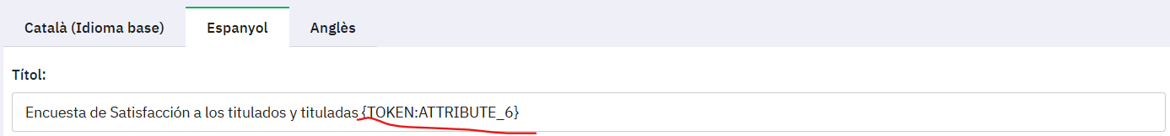
Screenshot 3 (Use of token attribute, language B)

Screenshot 4 (Screen output for user with language B)
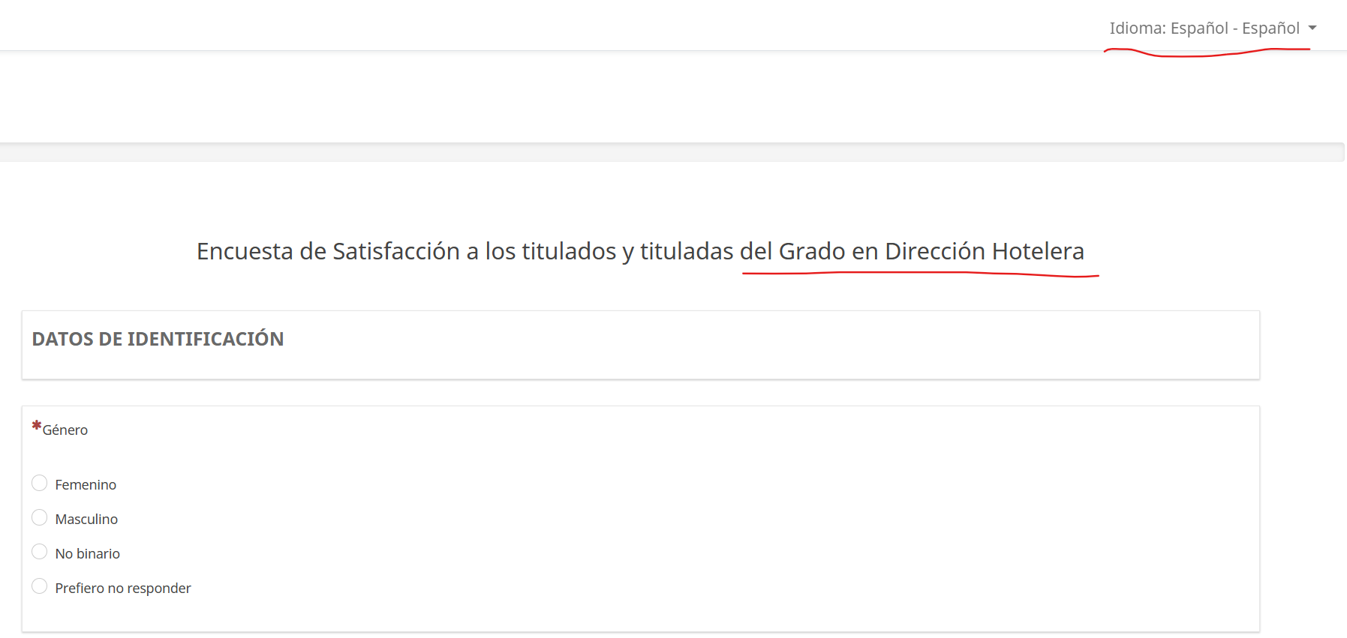
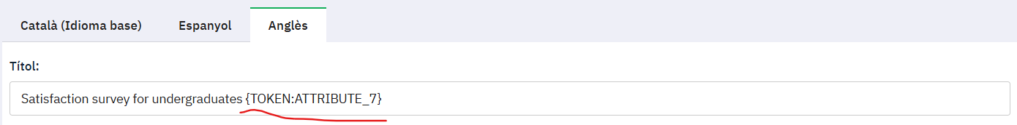
Screenshot 5 (Use of token attribute, language C)

Screenshot 6 (Screen output for user with language C)
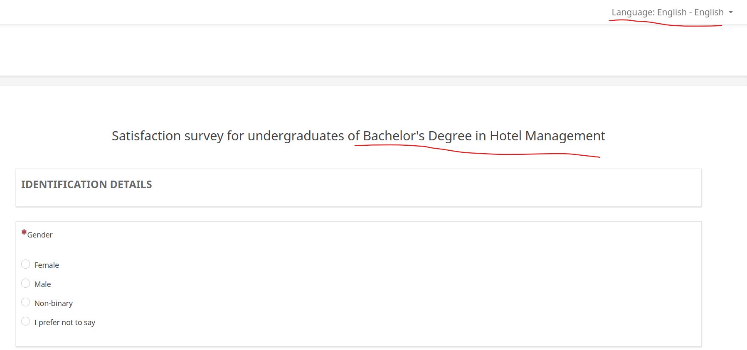

Step 2: The issue
The issue is that when I start the survey and switch languages using the top-menu language switcher, the attribute information disappears. It doesn’t matter the initial language (language A, B or C). I use as initial language in the screenshots example language A.

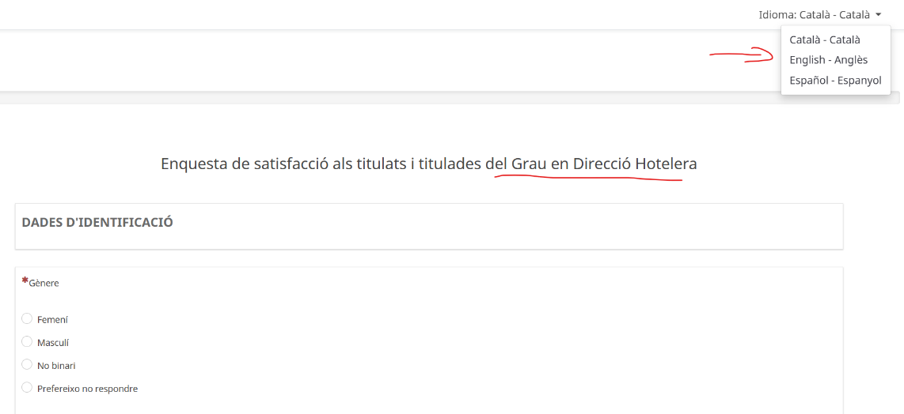
Screenshot 7 (Language change)

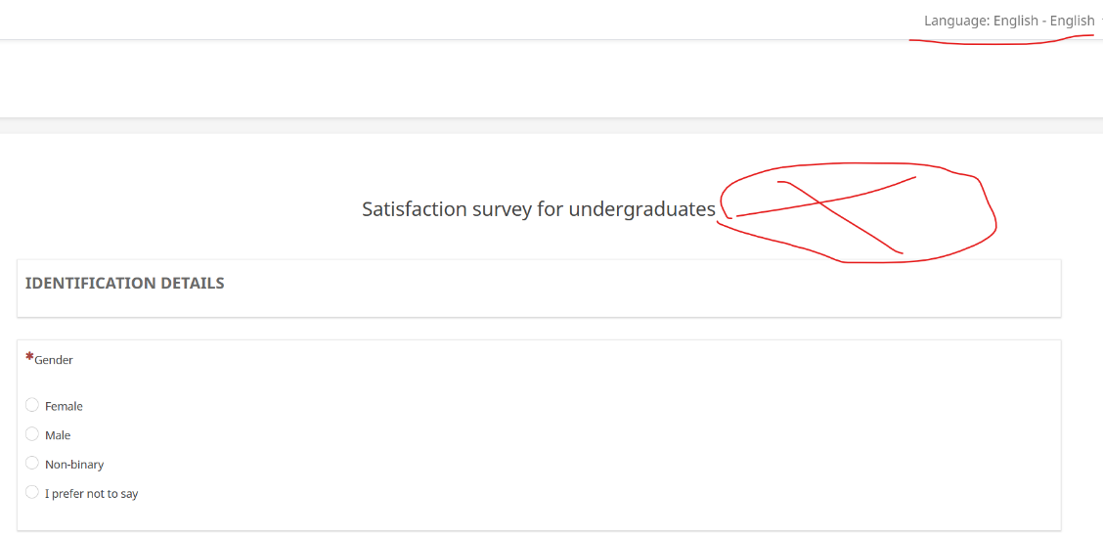
Screenshot 8 (Language changed)

Step 3: Other scenarios
Secondly, I tested whether the token information is stored after first "next" click. To do so, I enabled the welcome page (which I usually skip to keep surveys as short as possible). Unfortunately, it didn’t work: if I change the language on page two or three of the survey, the same issue occurs.
On the other hand, I noticed that if I change the language on the welcome page —whether using the top-menu language switcher or the specific language switcher on that page—, there's no issue with the token information throughout the rest of the survey.

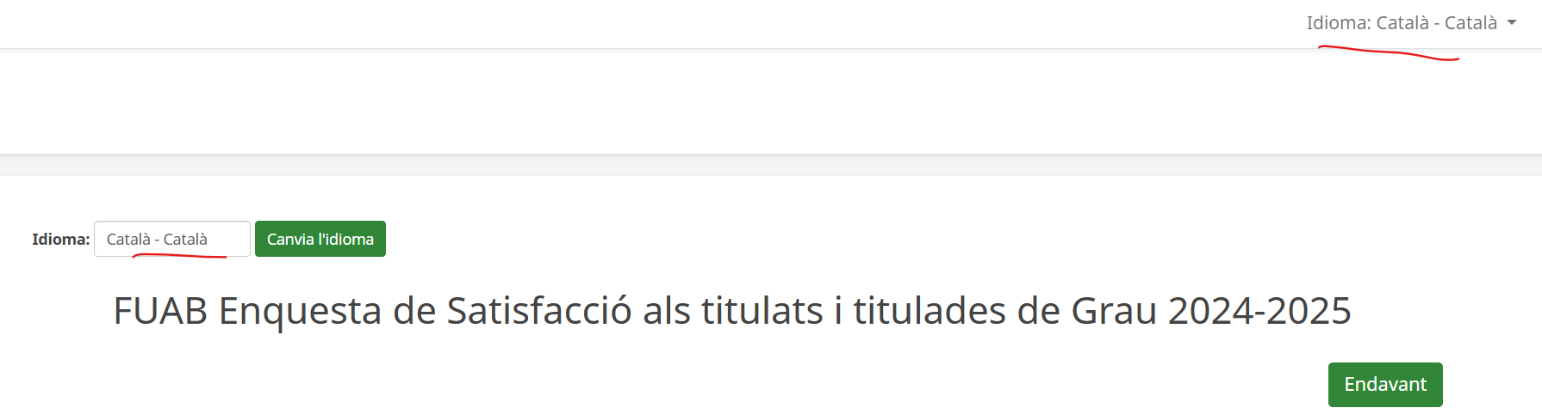
Screenshot 9 (Initial language at the welcome page)

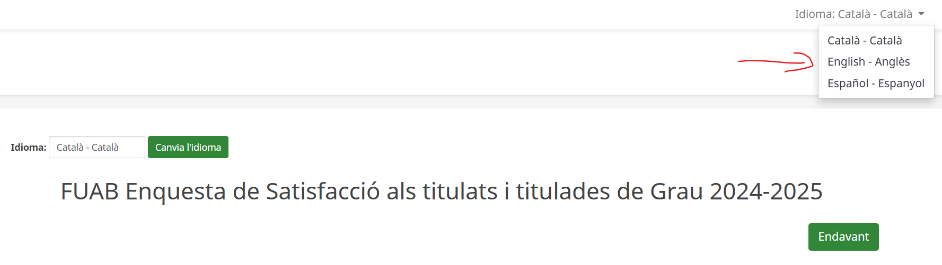
Screenshot 10 (Language change)

Screenshot 11 (Language changed)
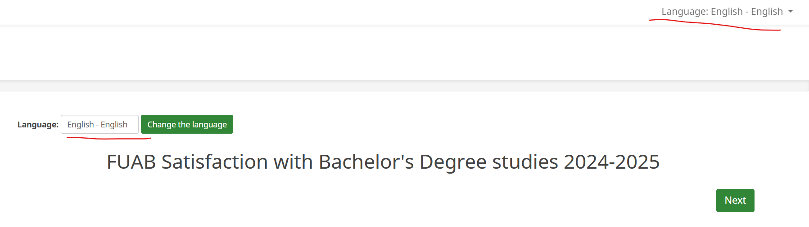
Screenshot 12 (Next page)
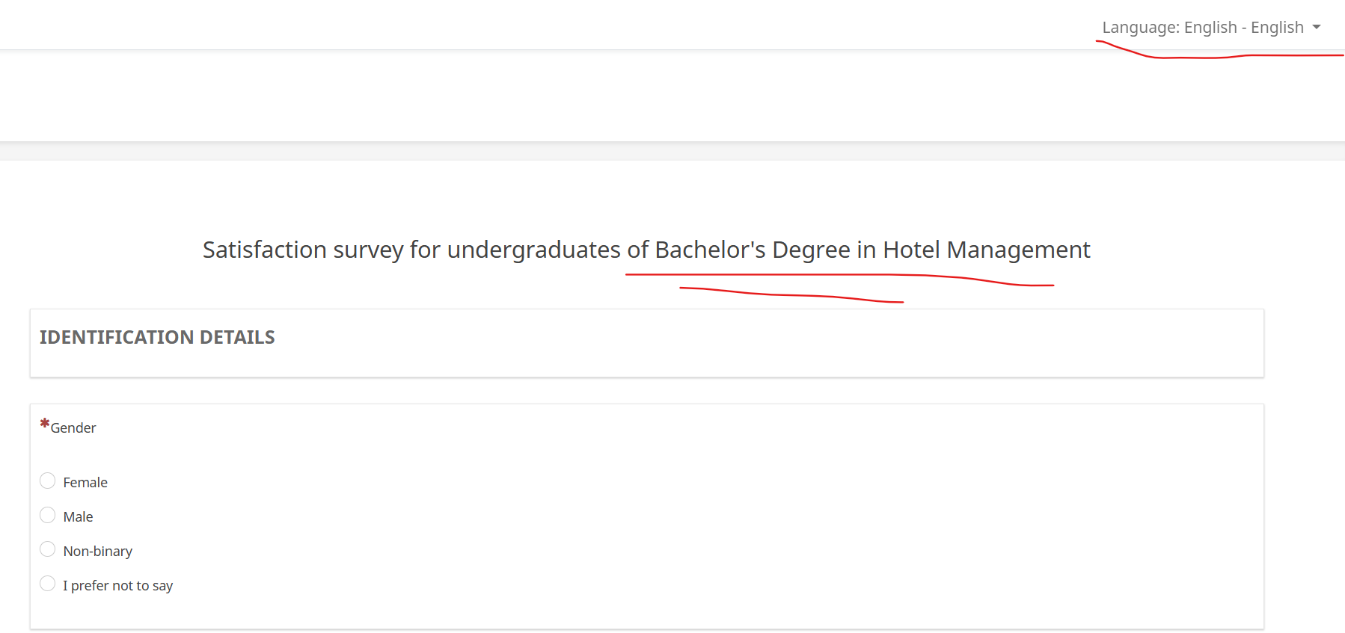
Finally, another scenario I tested was going forward, answering some questions, then going back to the welcome page and changing the language (either using top-menu language switcher or welcome page language switcher). In this case, the issue also occurs. So, it seems the bug is somewhat more complex; it is not just a top-menu language switcher problem through the survey.
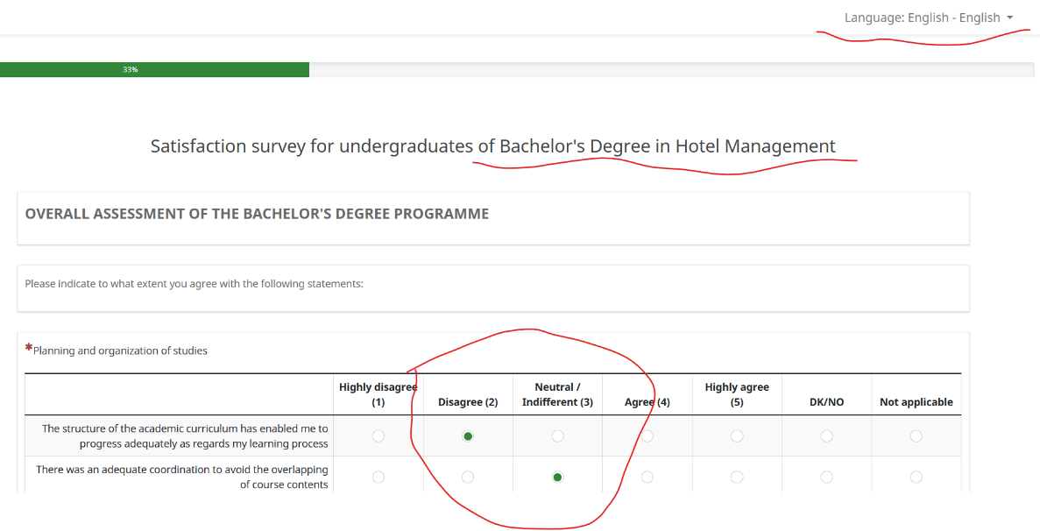
Screenshot 12 (Page 2, also with answers in page 1)

Screenshot 13 (Page 1 with answers)
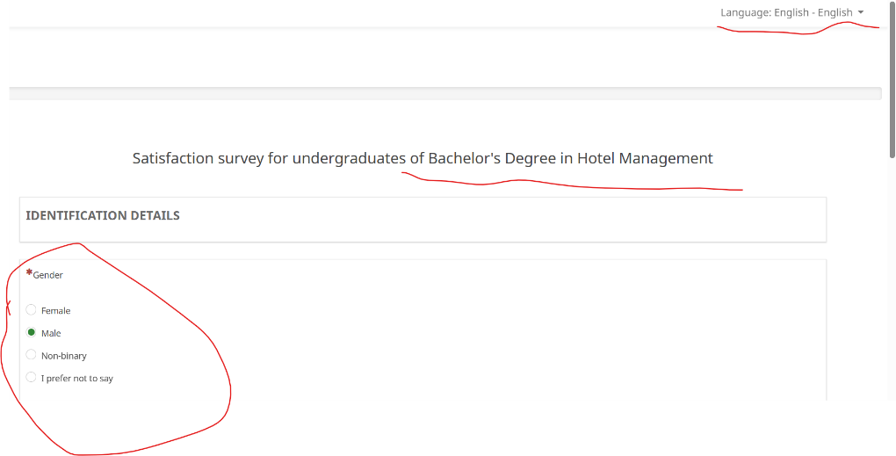

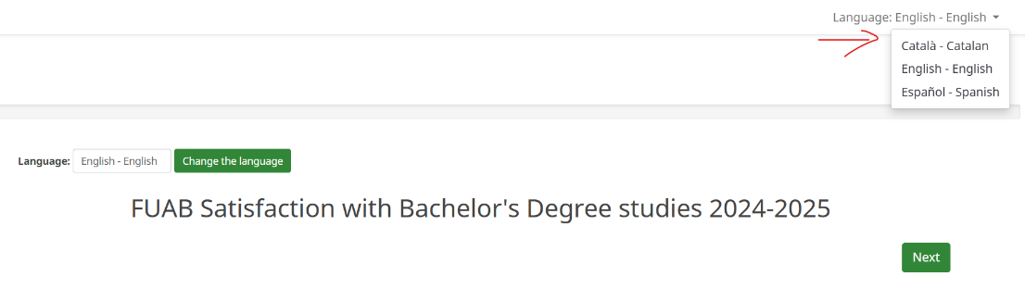
Screenshot 14 (Language change in welcome page)
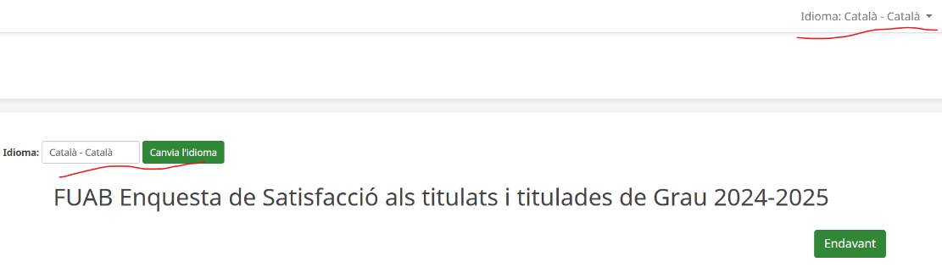
Screenshot 15 (Language changed)

Screenshot 16 (Come forward to page 1 with answers)
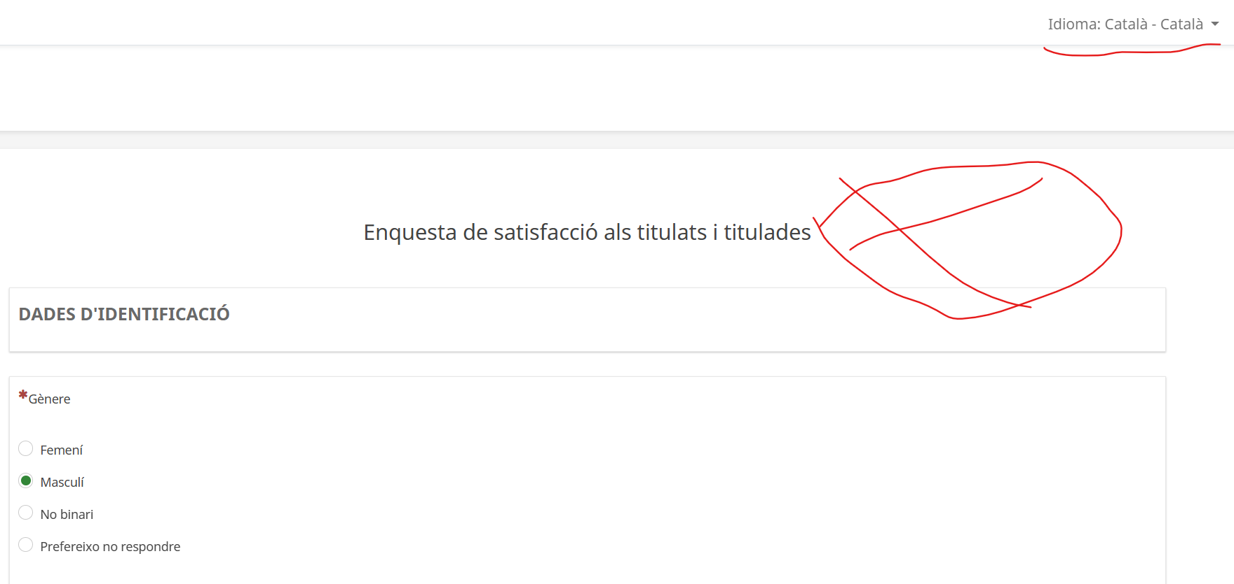

Screenshot 16 (Come forward to page 2 with answers)
