- The title of the survey is not appearing on importing an existing survey
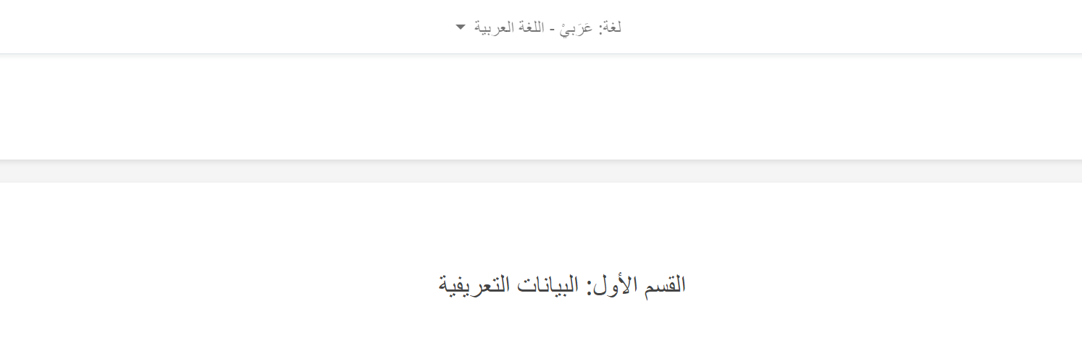
- Label for other option when a survey is copied appears as “???”
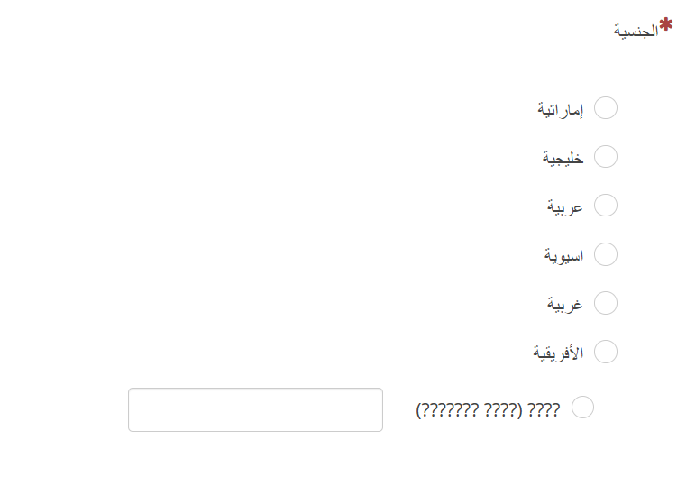
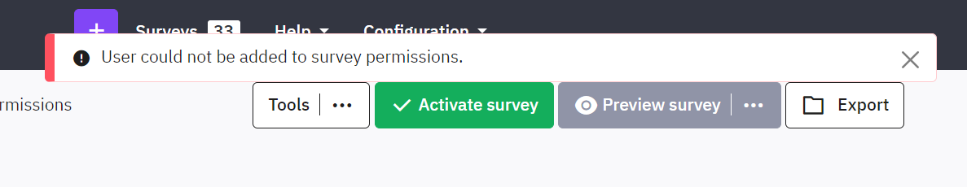

- Image upload in theme page is not working.
- The changes done on theme are not reflected

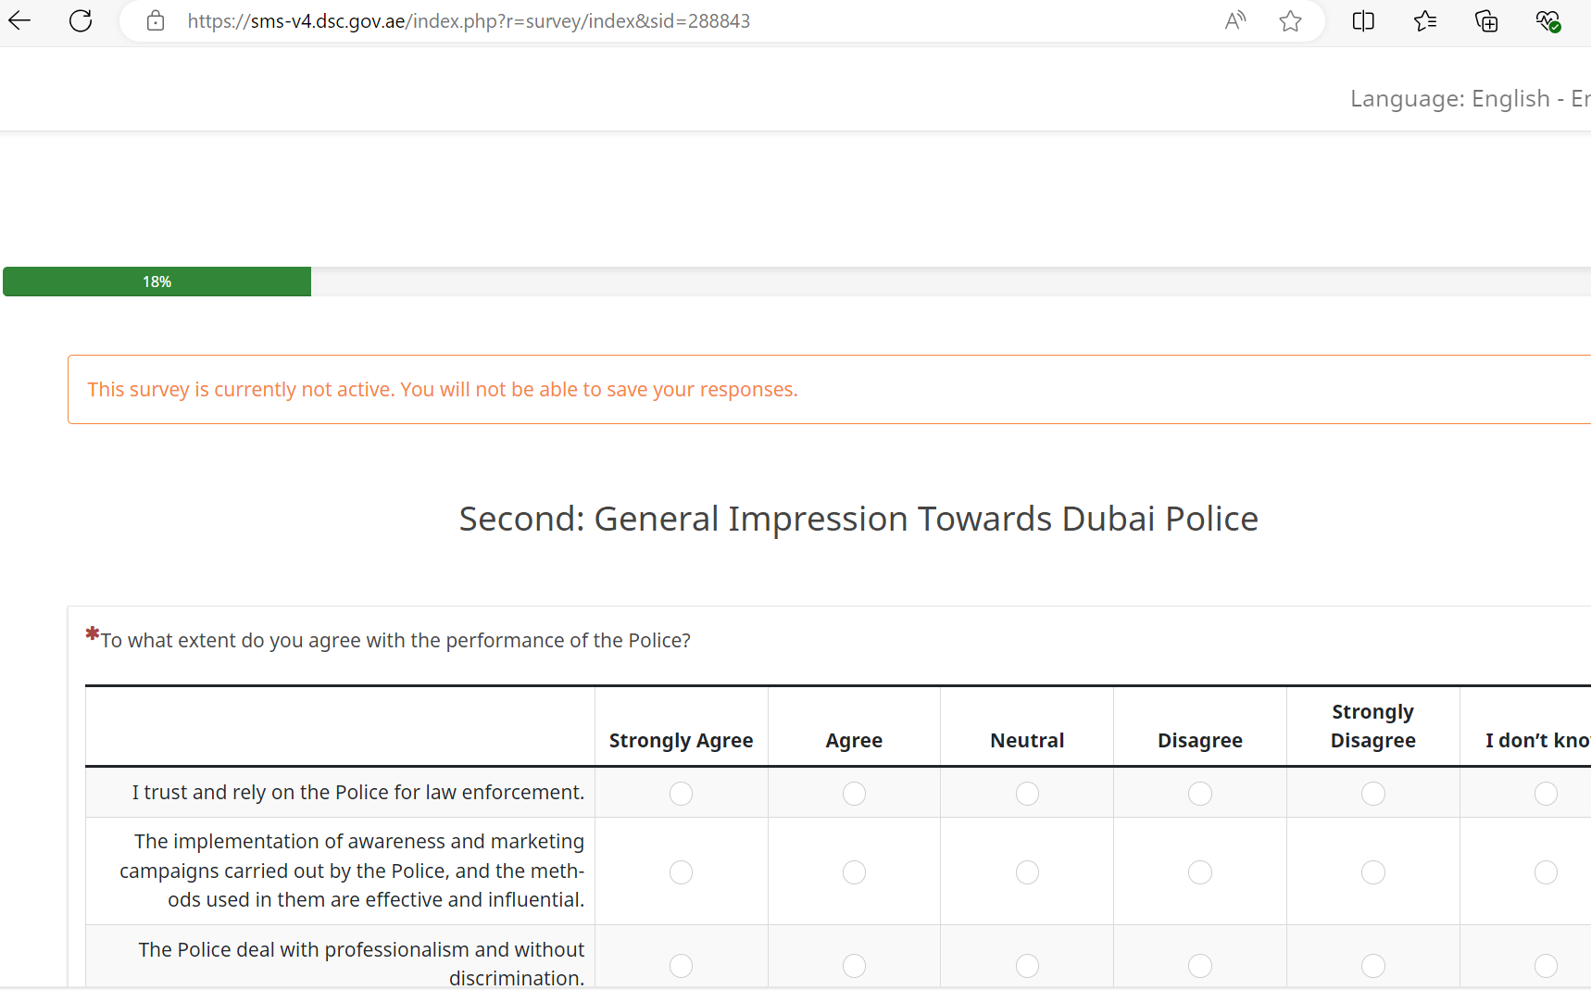

- Text alignment in array questions, for both language AR and EN need to be fixed.

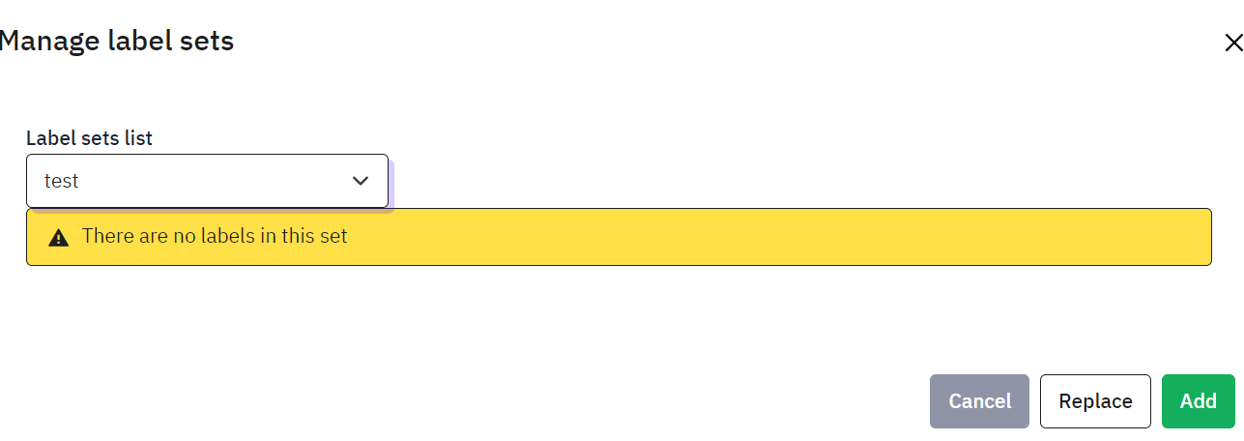
- Saving and adjusting the label sets is not working in a proper way.

