Survey group management
Version 1.1.à

Current situation :
- Super admin have rights on all Survey group
- Other user can not : create group, update group etc …
- User with only 'Create survey' didn't see any group (see issue 16428)
- User with Read/update/delete All survey can see all Survey group
- Other user muts be checked (see comment)

Then finally : except if all user are super-admin : this make Surey group usage less interesting, but more this must be used with care.

Proposed solution

Create a Global Permission for Survey groups
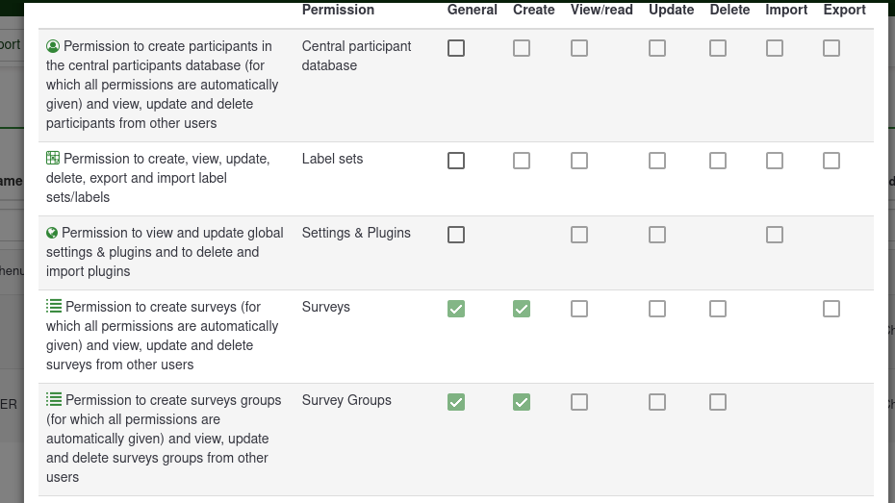
When update (adding feature) : Permission on groups are taken by current Surveyb permission. No change on situation

Create a Permission by Survey groups
Add the owner : the owner have all rigts on content of this group.
Add a User management for Permission : same then Survey but with less Permission

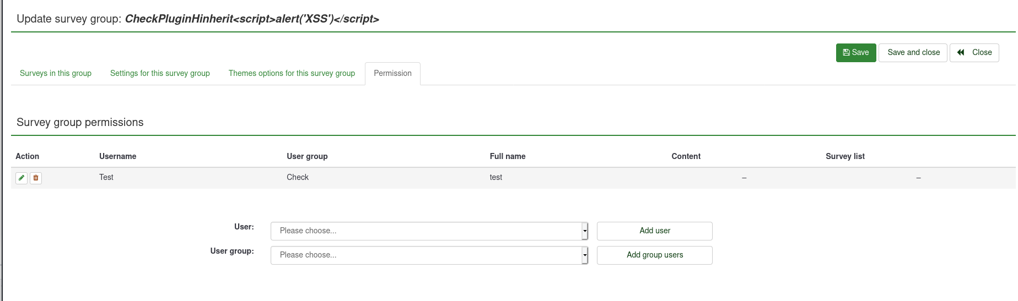
The proposed permission was
- Group : allow to update title, name, description (and owner ) of this Survey group
Read allow user to see the group in the list (then move survey in this group, if he have rights on this surey).
- Survey group security : Alow to set permission for other user
- Survey settings : Update survey settings : maybe move to Surveys in group ? Maybe use it for Theme options too ?
- Surveys in group : Same options than global settings, except create already in Survey group / read Permssion
Did we need "Themes options for this survey group" ? Can be in "Survey group" ? Or in "Surveys iun group" ? Or specific, see Survey settings
Add a "always show ro all user" this allow to create «public» groups. See https://bugs.limesurvey.org/view.php?id=16440#c60297

User case

Global with user with only Create survey
An user (with create survey only right) want to manage more easily his sureys : he have a Draft + Online + Archived Survey groups.
Another user (with only create survey) can not see his group and can have the same groups name.

User with only Create survey and some other without any rights
- An user can create surveyt
- Put this survey in "Departement" Group (he have Read right)
- User with Surveygroups/Surveys in group read right can check the survey : user don't have to give access.
- A new user enter in Department : just add it in Surveygroups/Surveys in group Right.

